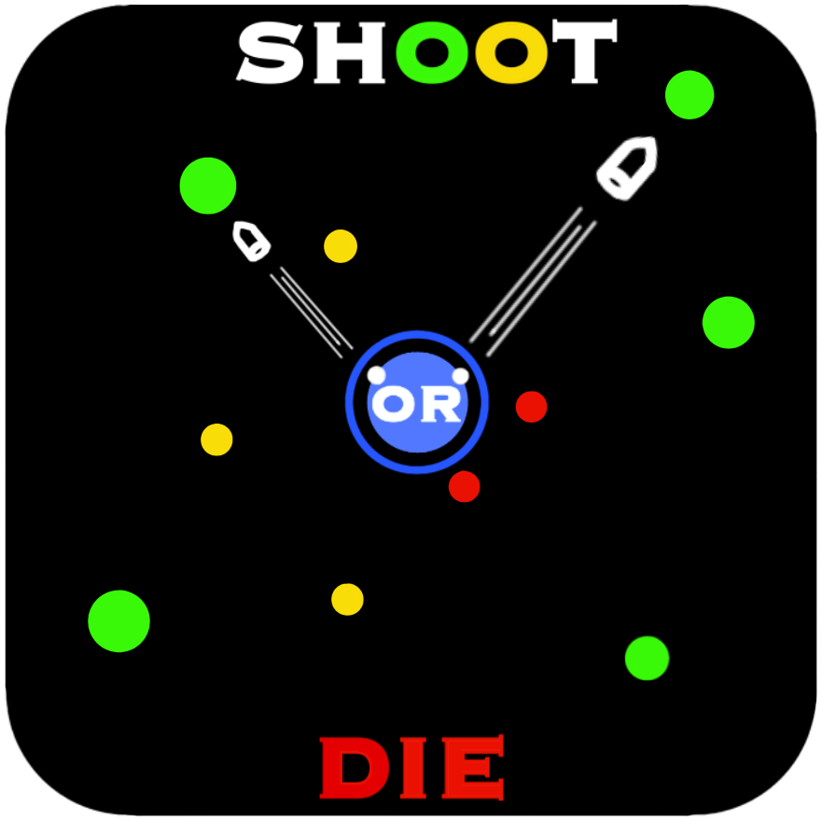

MINI PROJECT – I

SYNOPSIS



Department of Computer Science & Application

**Institute of Engineering & Technology**

SUBMITTED TO: - SUBMITTED BY: -

Dr. MANOJ VARSHNEY SURYANSH VERMA(201500726)

UMANG GUPTA (201500752) RIPUNJAY YADAV (201500562)

ARYAN CHOUDHARY (201500147)



# Acknowledgement

It gives us a great sense of pleasure to present the synopsis of the B.Tech mini project undertaken during B.Tech III Year. This project is going to be an acknowledgement to the inspiration, drive and technical assistance will be contributed to it by many individuals. We owe special debt of gratitude to D r. Manoj varshney , Technical Trainer , for providing us with an encouraging platform to develop this project, which thus helped us in shaping our abilities towards a constructive goal and for his constant support and guidance to our work.

His sincerity, thoroughness and perseverance has been a constant source of inspiration for us. We believe that he will shower us with all his extensively experienced ideas and insightful comments at different stages of the project & also taught us about the latest industry-oriented technologies. We also do not like miss the opportunity to acknowledge the contribution of all faculty members of the department for their kind guidance and co-operation.

SURYANSH VERMA (201500726)

Umang Gupta(201500752)

Ripunjay Yadav(201500562)

Aryan Chaudhary (201500147)

ABSTRACT

The shooting game is a simple web-based game created using HTML, CSS, and JavaScript. The objective of the game is to shoot as many targets as possible within a certain time limit. The game is presented in a 2D environment, with the player controlling a character that can move left and right on the screen. The targets are randomly generated and move across the screen from right to left at varying speeds. The player can shoot the targets by clicking on them, and each successful hit earns points. The game ends when the time limit is reached, and the player's score is displayed. The game features sound effects for shooting and hitting targets, and the player can restart the game at any time. The game is designed to be easy to play, with intuitive controls and clear visual feedback.

The game is built using HTML for the overall structure of the game, CSS for styling and layout, and JavaScript for game logic and interactivity. The game screen is divided into multiple sections using HTML and CSS, with one section displaying the player's score and remaining time, and another section displaying the game canvas where the targets move and the player shoots. The game canvas is created using HTML5 canvas element and is dynamically updated with new targets as they are generated.

The game logic is implemented using JavaScript, which handles the movement of the targets and collision detection when the player shoots. The player's character is controlled using keyboard input, with left and right arrow keys used for movement. When the player clicks on a target, the game calculates if the player hit the target and adds points to the score if successful. A countdown timer is also implemented using JavaScript to ensure the game ends after a set time limit.

The game features simple graphics and sound effects, with images of targets and the player's character created using HTML and CSS. Sound effects for shooting and hitting targets are implemented using JavaScript audio API.

Overall, the shooting game provides a fun and engaging experience for players, with intuitive controls and simple gameplay mechanics. It demonstrates the power of HTML, CSS, and JavaScript in creating interactive web-based games.



# Contents

Abstract Declaration Acknowledgement

1. Introduction
   1. Objective
   2. Motivation
   3. Problem Statement
2. Software Requirement
   1. Hardware Requirements
   2. Software Requirements
3. Project Description
4. Working
5. Implementation
6. References



# INTRODUCTION

Welcome to our exciting new shooting game! In this game, you will take on the role of a skilled marksman tasked with taking down a variety of targets with your trusty firearm. Using your quick reflexes and sharp aim, you'll need to blast your way through a series of challenging levels, each one more difficult than the last.

Powered by HTML5, CSS, and JavaScript, this game is easy to play and accessible to gamers of all skill levels. With stunning graphics and realistic sound effects, you'll feel like you're really in the middle of the action. So load up your weapon, take aim, and get ready to put your shooting skills to the test!

As you progress through the levels, you'll encounter a variety of obstacles and challenges that will test your shooting skills to the limit. You'll need to take down moving targets, shoot from different angles, and even deal with unexpected surprises like moving barriers or hidden enemies.

But don't worry, you won't be alone in your mission. You'll have access to a range of powerful weapons and upgrades that will help you overcome even the toughest challenges. Whether you prefer a classic handgun, a powerful shotgun, or a high-tech sniper rifle, there's a weapon that's perfect for your play style.

And if you're looking for even more of a challenge, you can take on other players in the multiplayer mode, where you'll compete head-to-head in fast-paced shooting matches. With leaderboards and rankings to track your progress, you'll always know where you stand in the competitive world of online gaming.

So what are you waiting for? Grab your weapon and get ready to take down some targets in this thrilling shooting game, powered by HTML5, CSS, and JavaScript.

Overall, our simple shooting game is a fun and addictive way to pass the time. It's easy to play but challenging to master, and it's a great way to test your hand-eye coordination and reflexes. So, give it a try and see how many targets you can hit!



## SOFTWARE AND HARDWARE REQUIREMENTS

* Visual studio code
* XAMPP
* Notepad
* Internet connection
* 4 GB Ram
* Window 10

## PROJECT DESCRIPTION

The shooting game is a simple web-based game created using HTML, CSS, and JavaScript. The objective of the game is to shoot as many targets as possible within a certain time limit. The game is presented in a 2D environment, with the player controlling a character that can move left and right on the screen. The targets are randomly generated and move across the screen from right to left at varying speeds. The player can shoot the targets by clicking on them, and each successful hit earns points. The game ends when the time limit is reached, and the player's score is displayed. The game features sound effects for shooting and hitting targets, and the player can restart the game at any time.

The project is divided into 3 modules – student, course expert and administrator. The roles of the modules are as follows:

* **Student :**

The student selects from various courses available. The

student **t**akes a test on a course. There might be courses, which has only test modules. Each question has multiple choices with only one correct answer. The test will be time bound. Student can see the test schedule. New Users will be able to register themselves in the system as students. All students will be able to modify their own profile. Student views previous test reports, receives feedback for a test taken Student can go to the discussion board and browse through questions and answers and discussing solutions of questions asked in test. Student can chat with course expert. Student can also send messages to the course expert.

* **Course Expert :**

Creating test questions for the course**,** test questions will reside in the Draft area if either it is saved while creating/modifying or it has been rejected by admin. Modifying test questions, deleting the entire test, browse through the tests that students have submitted, just as a student would., view the results of those students that have taken test for his courses. Replying back to the messages from students.

* **Administrator:**

Publish tests submitted by Course Experts. Before

publishing test questions it is customary to get it reviewed by admin. After going through its content either it gets approved or gets rejected**.** Modify the profile of other users registered in the system. Change user status from inactive to active.

## WORKING

1.The game starts with a title screen where the player can choose to start the game or read the instructions.

2.Once the player starts the game, they will be presented with a playing area where the target is positioned at the center of the screen.

3.The player's character is positioned at the bottom of the screen, with enemies appearing at the top and advancing towards the target.

4.The player can move their character left and right using the arrow keys on their keyboard.

5.The player can also shoot their firearm by pressing the space bar, causing a bullet to be fired upwards towards the enemies.

6.If a bullet collides with an enemy, the enemy is destroyed, and the player's score is increased.

7.If an enemy reaches the target, the player loses one of their lives. The game ends if the player loses all of their lives.

8.The game continues until the player loses all their lives or completes all the levels.

As the game progresses, the enemies become faster and more difficult to hit, providing an increasingly challenging experience. The player's score is displayed at the top of the screen, along with their remaining lives and the level they are currently on. The game is designed to be fast-paced and exciting, with the goal of providing a satisfying shooting experience for the player.



## 

## IMPLEMENTATION

1.Create the game canvas: Start by creating a canvas element in your HTML file. This is where the game graphics will be rendered. You'll also need to set the canvas dimensions and styles using CSS.

2.Load game assets: Before the game can begin, you'll need to load all the necessary game assets such as images, sounds, and fonts. You can use the HTML5 audio and image tags to load these assets.

3.Create game objects: Next, you'll need to create game objects such as the player, enemies, and bullets. You can use JavaScript classes or functions to define these objects and their properties.

4.Implement game logic: Now it's time to implement the game logic. This includes things like handling user input (such as mouse clicks and keyboard events), updating the game state (such as moving the player and enemies), and detecting collisions (such as when a bullet hits an enemy).

5.Draw the game: With the game logic in place, you can now draw the game graphics on the canvas. You can use JavaScript functions like requestAnimationFrame() to update the canvas and create animations.

6.Add game UI: Finally, you can add a game user interface (UI) to display information such as the score, health, and game level. You can use HTML and CSS to create the UI elements and JavaScript to update them based on the game state.

That's a basic overview of how you could implement a simple shooting game using HTML5, CSS, and JavaScript. Of course, the actual implementation will depend on the specific game mechanics and design that you have in mind.

## REFERENCES;

**Books:**

* Head First HTML and CSS

A Learner's Guide to Creating Standards- Based Web Pages Elisabeth Robin

Eric Freeman

* HTML & CSS : design and Build websites
* Learning Web design
* HTML 5
* JAVAScript



**Websites:**

* [www.w3schools.co](http://www.java.sun.com/)m
* [www.GeeksforGe](http://www.google.com/)eks.com
* [www.javatpoint.com](http://www.javawrench.com/)
* [www.codecademy.co](http://www.javaworld.com/)m
* [www.projectdeveloper.com](http://www.projectdeveloper.com/)

## Faculty Guidelines:

Dr. Manoj varshney

## Github Repository link

https://github.com/Suryanshverma213202/shoot-or-die